**Microsoft Analysis Services**

**Microsoft SQL Server Analysis Services**, SSAS,[[1]](https://en.wikipedia.org/wiki/Microsoft_Analysis_Services#cite_note-1) is an online analytical processing ([OLAP](https://en.wikipedia.org/wiki/Online_analytical_processing)) and [data mining](https://en.wikipedia.org/wiki/Data_mining) tool in [Microsoft SQL Server](https://en.wikipedia.org/wiki/Microsoft_SQL_Server). SSAS is used as a tool by organizations to analyze and make sense of information possibly spread out across multiple databases, or in disparate tables or files. [Microsoft](https://en.wikipedia.org/wiki/Microsoft) has included a number of services in SQL Server related to [business intelligence](https://en.wikipedia.org/wiki/Business_intelligence) and [data warehousing](https://en.wikipedia.org/wiki/Data_warehousing). These services include Integration Services, Reporting Services and Analysis Services. Analysis Services includes a group of OLAP and [data mining](https://en.wikipedia.org/wiki/Data_mining) capabilities and comes in two flavors - Multidimensional and Tabular.

Introduction and sample Example :

<https://www.youtube.com/watch?v=1SzxZ9A6nqI>

This service is used to analyze huge amounts of data and apply to business decisions. It is also used to create two or multidimensional business models.

Modes

There are two modes − Native Mode (SQL Server Mode) and Share Point Mode.

Models

There are two models − Tabular Model (For Team and Personal Analysis) and Multi Dimensions Model (For Corporate Analysis).

Architecture of SSAS

[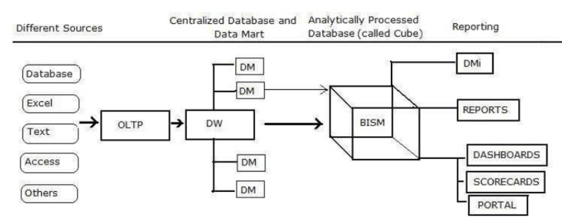](https://www.guru99.com/images/1/060719_0652_SSASTutoria1.png)

Type of Models in SSAS

Multi-Dimensional Data Model

The Multi-Dimensional Data Model, which consists of a data cube. It is a group of operations which allows you to query the value of cells by using cube and dimension members as coordinates.

It defines rules which decide the way that measure values are rolled up within hierarchies or how specific values are computed in a sparse cube.

Tabular Modeling

Tabular modeling organizes data into related tables. The table doesn't designate as "dimensions" or "facts" and development time is less with tabular because of all related tables able to serve both roles.

Example 2 :

<https://www.sqlshack.com/build-cube-scratch-using-sql-server-analysis-services-ssas/>

Sql Jobs

A job is a specified series of operations performed sequentially by SQL Server Agent. A job can perform a wide range of activities, including running Transact-SQL scripts, command prompt applications, Microsoft ActiveX scripts, Integration Services packages, Analysis Services commands and queries, or Replication tasks. Jobs can run repetitive or schedulable tasks, and they can automatically notify users of job status by generating alerts, thereby greatly simplifying SQL Server administration.

To create a job, a user must be a member of one of the SQL Server Agent fixed database roles or the **sysadmin** fixed server role. A job can be edited only by its owner or members of the **sysadmin** role. Members of the **sysadmin** role can assign job ownership to other users, and they can run any job, regardless of the job owner.

Creating and running sql Jobs :

<https://www.youtube.com/watch?v=svstYRLthJY>